INTERNATIONAL TRAINING WORKSHOP

Land Readjustment: Tools for Urban Regeneration
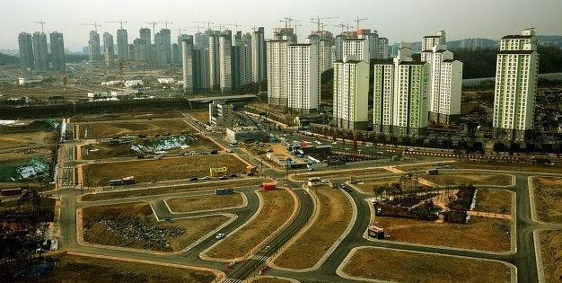
Venue and Place: International Urban Training Centre (IUTC), Republic of Korea
Dates: 12-15 December 2016
Coordination: UN-HABITAT & IUTC
Sponsorship: Gangwon Provincial Government, ROK

WOKSHOP SCHEDULE

Date | Session | Time block | Topic | Resource person(s)
Monday, 12 December
 | 1 | 9:00-9:30 | Orientation and Introduction
 | 2 | 9:30-10:45 | Land readjustment and urban regeneration: overall introduction (part 1) | Prof. Barrie Needham
 |  |  | Coffee break
 | 3 | 11:00 -12:30 | Opening ceremony | Gangwon Province
 |  | 12:30-13:30 | Lunch
 | 4 | 13:30-15:00 | Land readjustment and urban regeneration: overall introduction (part 2) | Prof. Barrie Needham
 |  | 15:00-15:15 | Coffee break
 | 5 | 15:15-16:15 | Land readjustment in emerging economies (module 1&2)  Introduction of role play exercise | MIT videos /T.Nguyen
 | 6 | 16:15-18:00 | Presentation of Korea Case on Land Readjustment | Prof. Kim, Kwi-Gon
 |  | 18:30-19:30 | Dinner
Tuesday, 13 December
 | 6 | 9:00-10:30 | The experiences in four countries with land readjustment – The Netherlands, Germany, Israel, Japan | Prof. Barrie Needham
 |  | 10:30-10:45 | Coffee break
 | 7 | 10:45-12:30 | Detroit--from catastrophe to recovery (key focus areas--regionalism as a driver of regeneration, targeting relevant sectors for regeneration, social aspects of regeneration e.g., safety and talent, role of corporations, utilities, and philanthropy in regeneration) | Britt Harter
 |  | 12:30-13:30 | Lunch
 | 8 | 13:30-16:30 | Learning from best practices in land readjustment in Asia (including a 15 minute coffee break) | Dr. Felipe Francisco De Souza
 |  | 16:30-16:20 | Coffee break
 | 9 | 16:20-18:00 | Land readjustment in emerging economies (module 3&4) | MIT/T.Nguyen
 |  | 18:30-19:30 | Dinner
 | 10 | 19:30-21:00 | Korean cultural evening
Wednesday, 14 December
 | 11 | 9:00-10:30 | Land Readjustment in emerging economies (part 3) – linkages to urban management policy development |  | MIT/T.Nguyen
 |  |  | Coffee break
 | 12 | 10:45-12:30 | Exercise and case study preparation |  | T. Nguyen and F. De Souza
 |  | 13:30-17:30 | Excursion
 |  | 18:00-17:30 | Dinner at IUTC
 | 13 | 20:00-21:30 | Group presentation preparation
Thursday, 15 December
 | 14 | 9:00-10:30 | Land readjustment in emerging economies (policy-implications for sustainable urban management) | Yu-hung Hong, MIT (Skype connection)
 |  | 10:30-10:45 | Coffee break
 | 15 | 10:45-12:30 | New York and Los Angeles--helping areas left behind in booming global cities (key focus areas--environmental opportunities in regeneration, broadband as regeneration driver, community engagement in regeneration) | Britt Harter
 |  | 12:30-13:30 | Lunch
 | 16 | 13:30-15:30 | Group work presentation | Dr. Felipe Francisco De Souza/T.Nguyen
 |  | 14:45-15:00 | Coffee break
 | 17 | 15:00-16:30 | Group work presentation | Dr. Felipe Francisco De Souza/T.Nguyen
 |  | 16:30-16:45 | Coffee break
 | 18 | 16:45-18:15 | Final Evaluation and Closing Ceremony | IUTC
 |  | 18:30-19:30 | FINAL Dinner
Friday, 16 December: Particpants’ departure from IUTC

Prof. Barrie Needham is Emeritus Professor from University of Nijmegen, the Netherlands
Britt Harter is Director in PwC’s Sustainable Business Solutions practice
Dr. Felipe Francisco De Souza is Technical Adviser for metropolitan governance at UN-Habitat Regional Office for Latin America and Caribbean.

